Attachment to the Public Sector PhD application:

Confirmation of participation in a doctoral project

This document is to be sent to the degree-conferring institution and signed.
The Research Council stipulates that applications submitted under the Public Sector PhD Scheme must be accompanied by written confirmation that the doctoral project reflects the strategic objectives of, and has been approved by the applying organisation (Project Owner), and that the doctoral project will be completed in a collaborative effort between the Project Owner and the degree-conferring institution.
Please note that the Research Council carries out an administrative review of applications for funding under this scheme. The degree-conferring institution is responsible for quality assurance of the scientific content of the doctoral project at the time of admission to a doctoral programme. Doctoral projects under the scheme must meet the same requirements for scientific quality set out for other doctoral projects undertaken at the institution and must follow the institution’s regulations for doctoral degree education with regard to admissions, implementation and evaluation.
The undersigned confirms that:
- the doctoral project has been planned and will be carried out in cooperation between the Project Owner and the degree-conferring institution
- The degree-conferring institution is willing to evaluate the candidate for admission to a relevant doctoral programme, and in this connection will carry out a scientific assessment of the project
- the degree-conferring institution and the Project Owner will draw up a collaboration agreement for the doctoral project provided the candidate is admitted to the doctoral programme
- the degree-conferring institution must ensure that all costs are communicated to the project owner (if applicable: both direct and indirect costs)
In addition, the Project Owner confirms the following:
- the doctoral project reflects the strategic objectives of, and has been approved by, decision-making bodies in the organisation
- the candidate will be employed by the company for the duration of the project period – also in the event of delays in the doctoral project, and the terms of the employment contract and working conditions are in compliance with Norwegian regulations
- adequate working hours and internal resources (supervision and funding) have been set aside to carry out the doctoral project

Further to Page 2: Signature page and Requirements for the collaboration agreement
It is not necessary for all signatures to appear on the same page, but please consolidate all signed pages into a single document and submit it as one attachment.
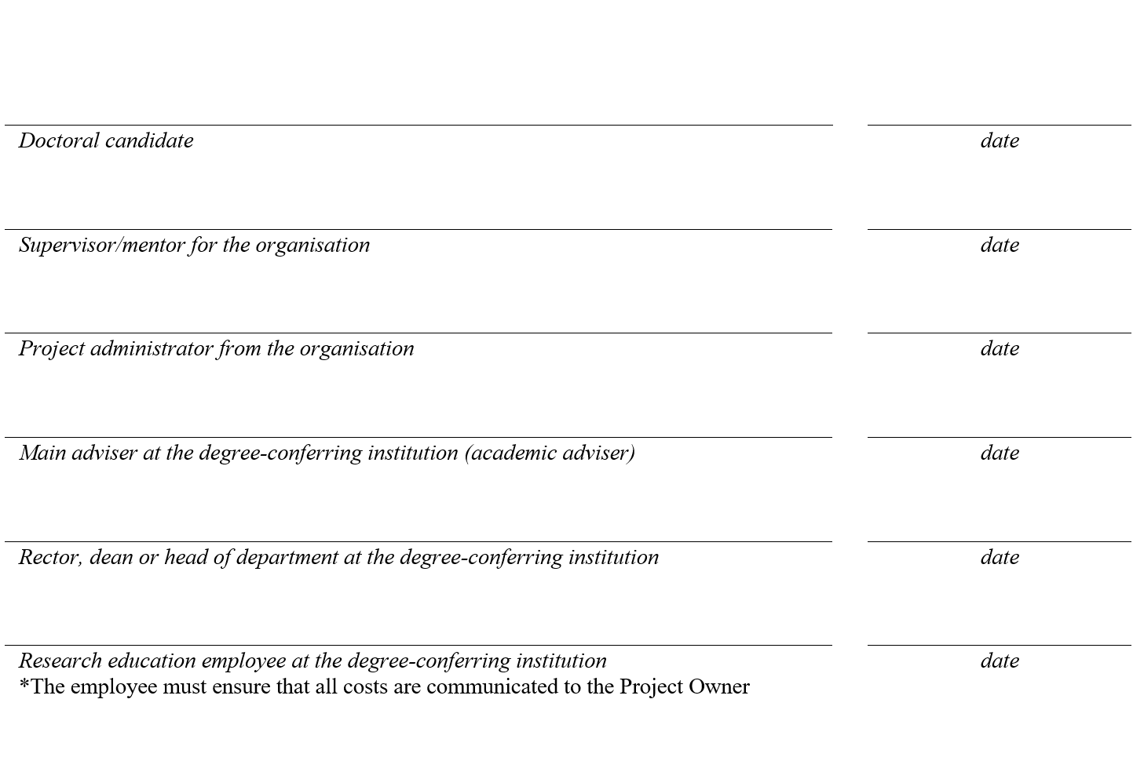
Requirements relating to the collaboration agreement between Project Owner and degree-conferring institution
All entities granted funding under the Public Sector PhD Scheme are required to sign a binding collaboration agreement with the degree-conferring institution involved.
Start drawing up the collaboration agreement early on
In our experience it can take time to get the agreement in place. Therefore, the Project Owner needs to initiate cooperation with the degree-conferring institution well before the grant application is to be submitted to the Research Council. The Project Owner may submit an application before the candidate has been admitted to the doctoral degree programme and a final collaboration agreement is in place. The Research Council will be able to process the application and may provide a funding pledge before these documents have been finalised, but will not sign the contract with the Project Owner before the collaboration agreement with the degree-conferring institution is signed and confirmation of admission to a doctoral programme has been received.
The collaboration agreement must at minimum include the following:
- the collaboration agreement is to apply for the entire project period. The project period is to be specified in the text of the agreement
- the ownership of results and issues pertaining to intellectual property rights must be adequately clarified
- the names, roles and employers of the supervisors from the degree-conferring institution and the company are to be specified
- the agreement must not prevent the candidate from publishing the results of his/her research and presenting them in his/her dissertation. This is to be specified in the agreement
- it must be specified that the candidate will spend at least one year at a degree-conferring institution and at least one year at the Project Owner. The time may be distributed in a manner that is most advantageous for the project
- it must be specified that the parties will conduct a collaboration meeting at least once per semester
- requirements relating to the work duties on the part of the doctoral candidate must be clarified. This item may also be incorporated into a separate employment agreement between the candidate and the company. In the case of four-year projects, the site where the candidate is to carry out his or her work duties must be specified
- project funding and the distribution of project costs for each partner participating in the doctoral project must be provided.
An admissions agreement may satisfy the above items
All doctoral degree candidates must sign an admissions agreement with the degree-conferring institution. Admissions agreements often comprise three sections (A, B, and C) where section C addresses cooperation with external parties. This agreement will in many cases include elements related to requirements under the Public Sector PhD Scheme. Any items not included in the above list must be added to the agreement.
The collaboration agreement must be signed at the proper level of authorisation
The agreement is to be signed by an individual with the formal authority to commit the degree-conferring institution at the departmental or faculty-head level. The academic adviser will generally not be authorised to sign the agreement unless he/she also has a key management position at the departmental or faculty level.
For the Project Owner, the project administrator is expected to have the authority required. The project administrator must be authorised to sign on behalf of the company, and to enter into a binding agreement with the Research Council.
Signing the contract between the Project Owner and the Research Council
When the collaboration agreement with the degree-conferring institution (and any other partners) has been drawn up and signed, the Project Owner is to upload it as an attachment to the contract with the Research Council. The contract will be published on “My RCN Web”. A copy of the documentation confirming admissions to a doctoral programme (i.e. a formal letter from the degree-conferring institution) must also be forwarded to the Research Council. This letter is to be sent to the case officer as an attachment to an email. The contract enters into force after the confirmation of admissions and the signed contract, including the signed collaboration agreement, are in place.

